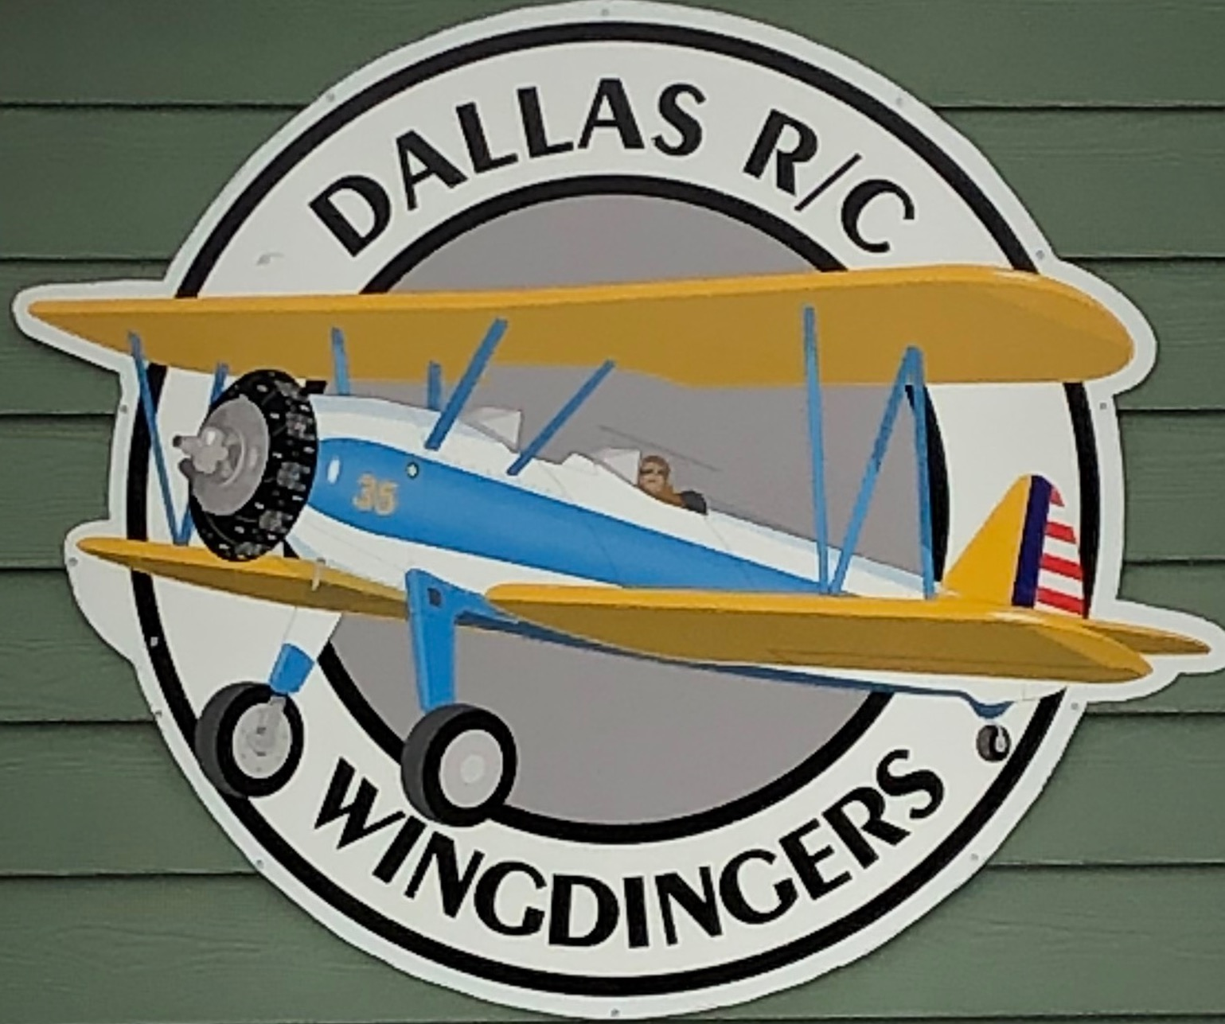
MEMBERSHIP INFORMATION AND APPLICATION
The following rules and regulations are part of being a member of the Dallas Wingdingers RC Club. They are designed to make flying safe and enjoyable for all members.

AMA MEMBERSHIP REQUIRED
1. Up to date AMA Card and AMA safety rules apply. Must be read and understood.
2. Club membership required to fly at our field.
3. Visiting flyers with AMA card welcome if accompanied by a current member.
4. Field rules are posted at the field, must be read, understood and abided by.
5. No flying under the influence of drugs or alcohol.
7. No radio on without frequency pin. 2.4 Ghz exempt.
8. No flying in a dangerous manner, safety first.
9. Keep flying field clean.
----------------------------------PLEASE PRINT LEDGIBLY==============================
Name ______________________________AMA No____________Exp.Mo/Yr______
Address____________________________________________Age_______________
City ______________________ Zip __________Phone____________________
Email ________________________ Emergency Contact _____________________
I will complete a successful radio ground test before the first flight of a new or repaired aircraft.
I will not fly without help from an experienced pilot until I am a qualified flyer. Experience In Years _______.
I will solo in the presence of a flight instructor to become a qualified flyer.
I will not fly over the pits, spectators or parking areas.
I have read and agree to abide by the rules of the Dallas Wingdingers RC Club. If I fail to abide by the rules of the AMA or those adopted by a vote of the Club Members, I will risk warnings by any member and/or expulsion from the Club by a vote of the Club Membership after proper discussion by the Club and the Violator if the Violator so chooses.

Signed _______________________________________Date ___________________
Regular Membership $40, Junior Membership Free (Under 19 years as of July 1), Membership is by the calendar year.
Mail to: Dallas Wingdingers PO Box 382, Dallas, Oregon 97338

